WEEK 5

📝 Introduction

In this tutorial, the emphasis will be made on configuring VLANs on a switch and a router to allow communication between VLANs. In Task 1, VLANs are configured on an OpenVSwitch to separate hosts into various broadcast domains. Task 2 involves a router being set up with VLAN sub-interfaces to enable communication between various VLANs.

Task 1 is creating VLANs in a switch to isolate hosts into various groups.
Task 2 enables a router to enable communication between VLANs.

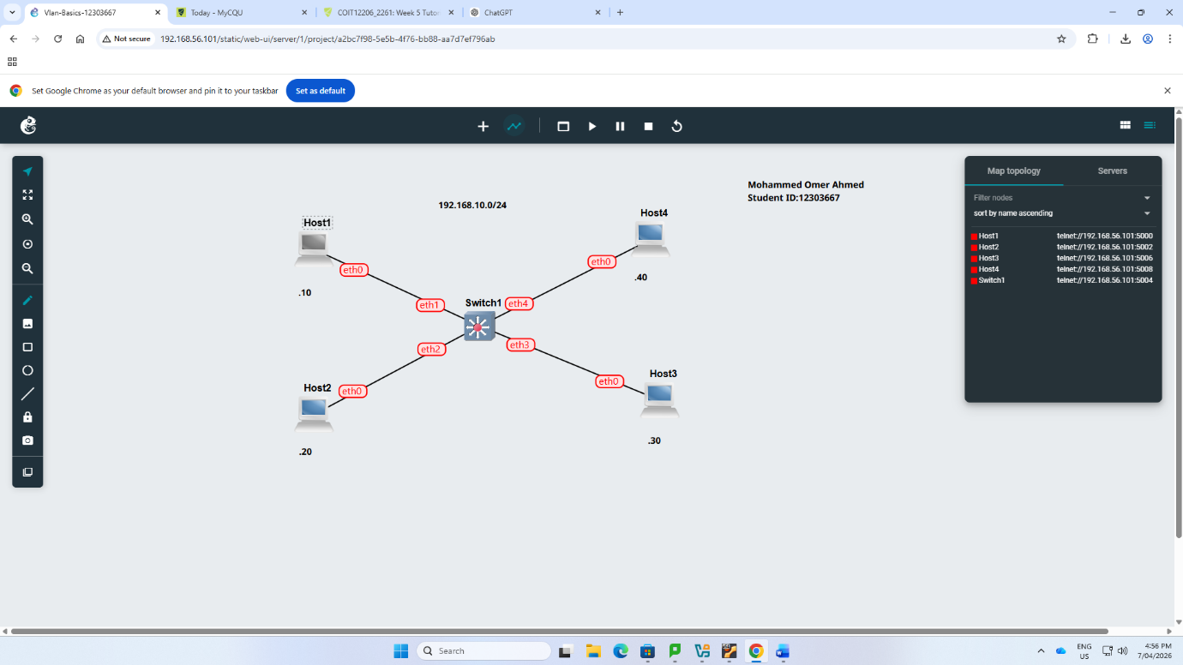
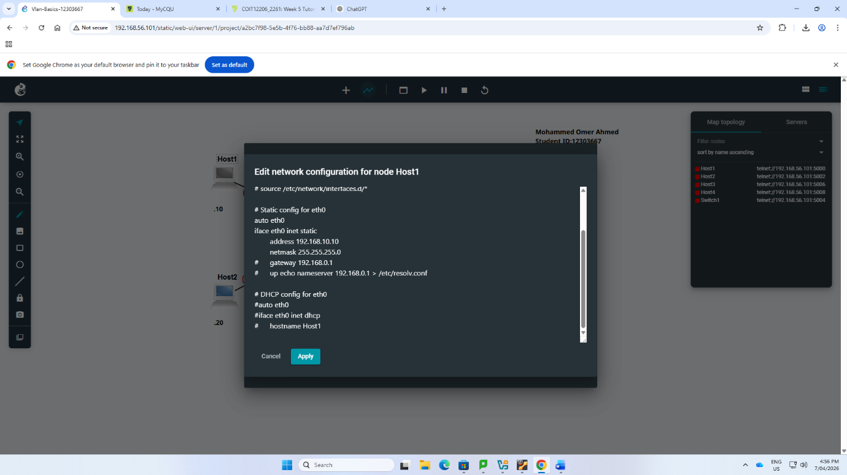
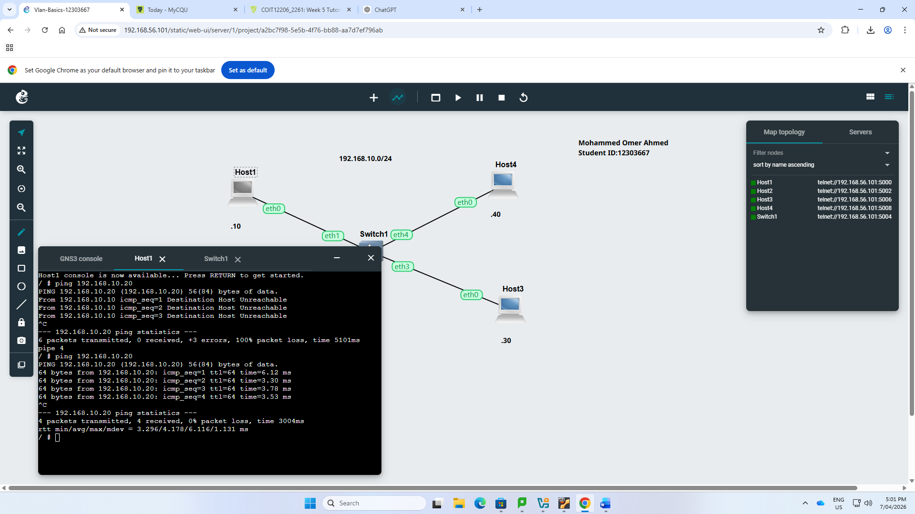
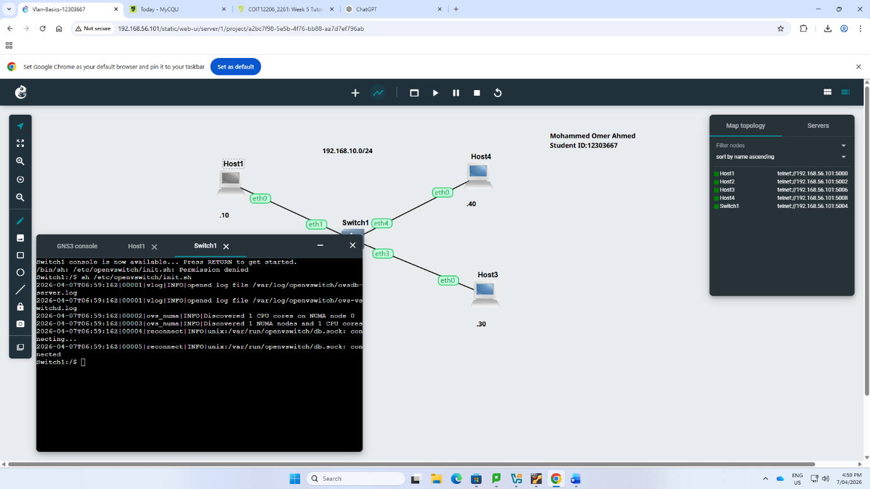
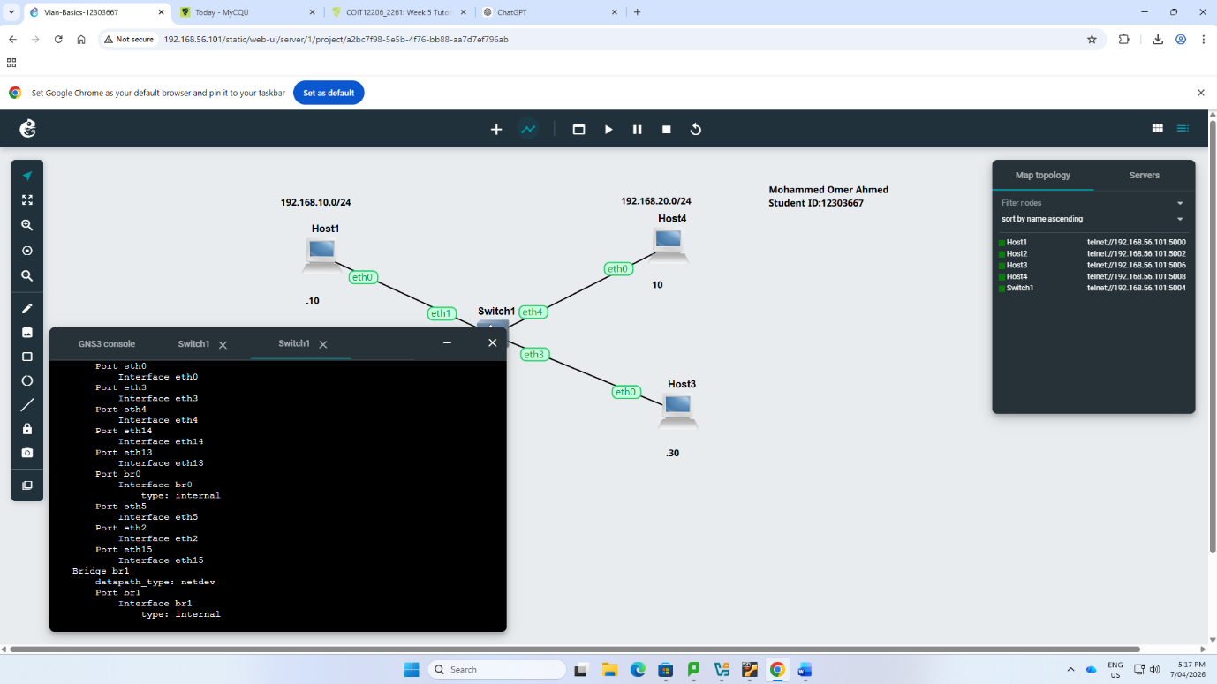
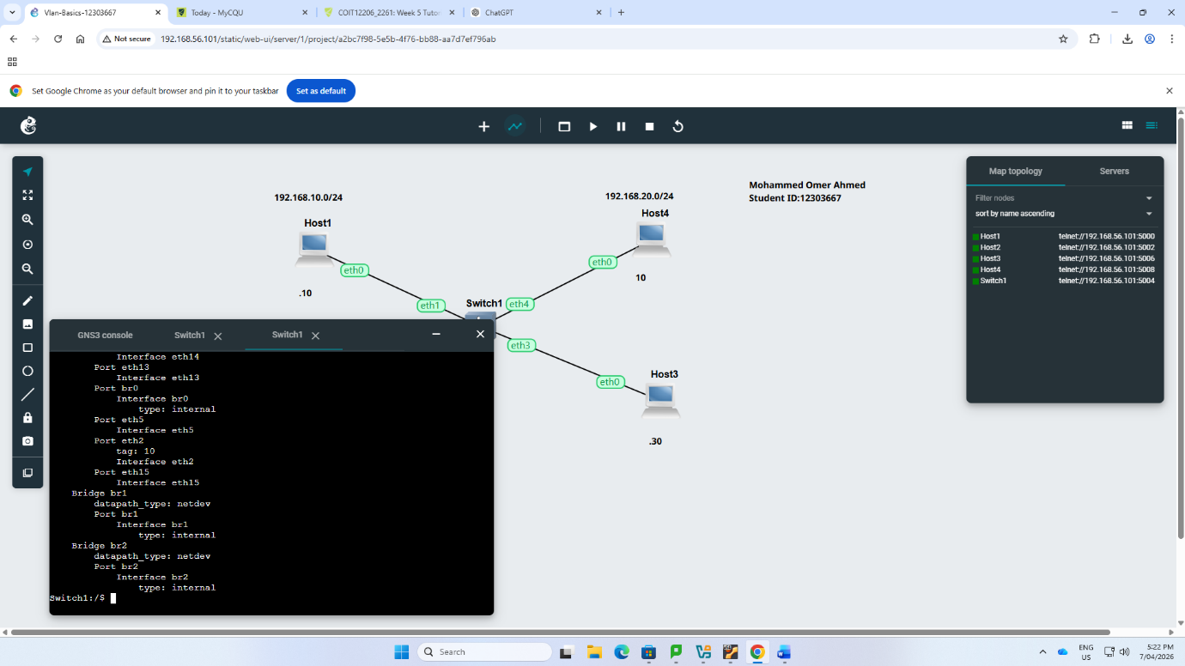
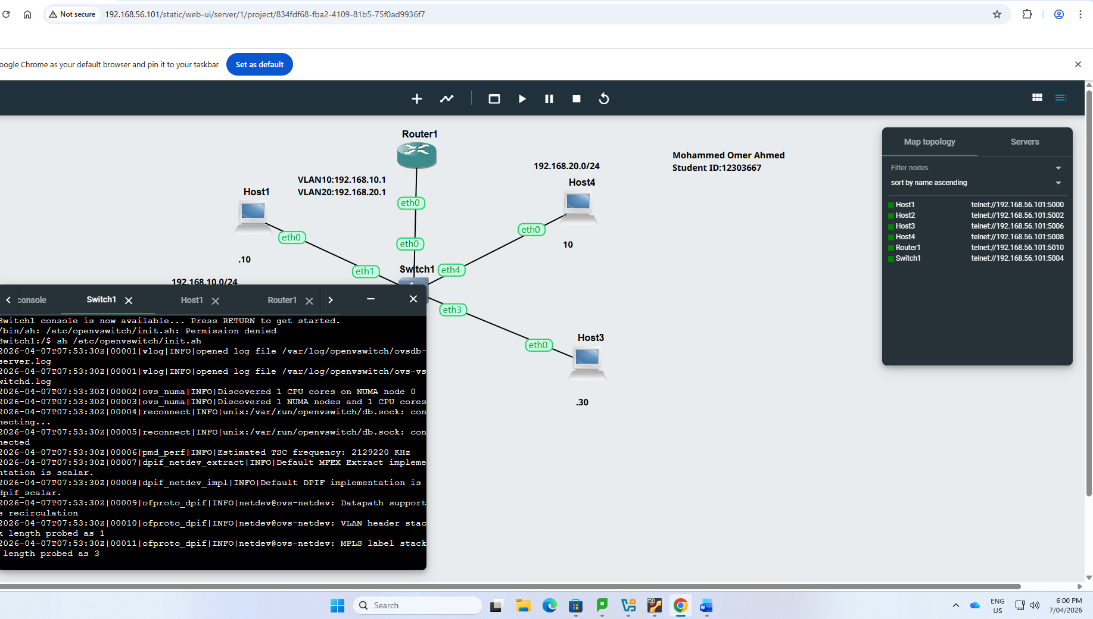
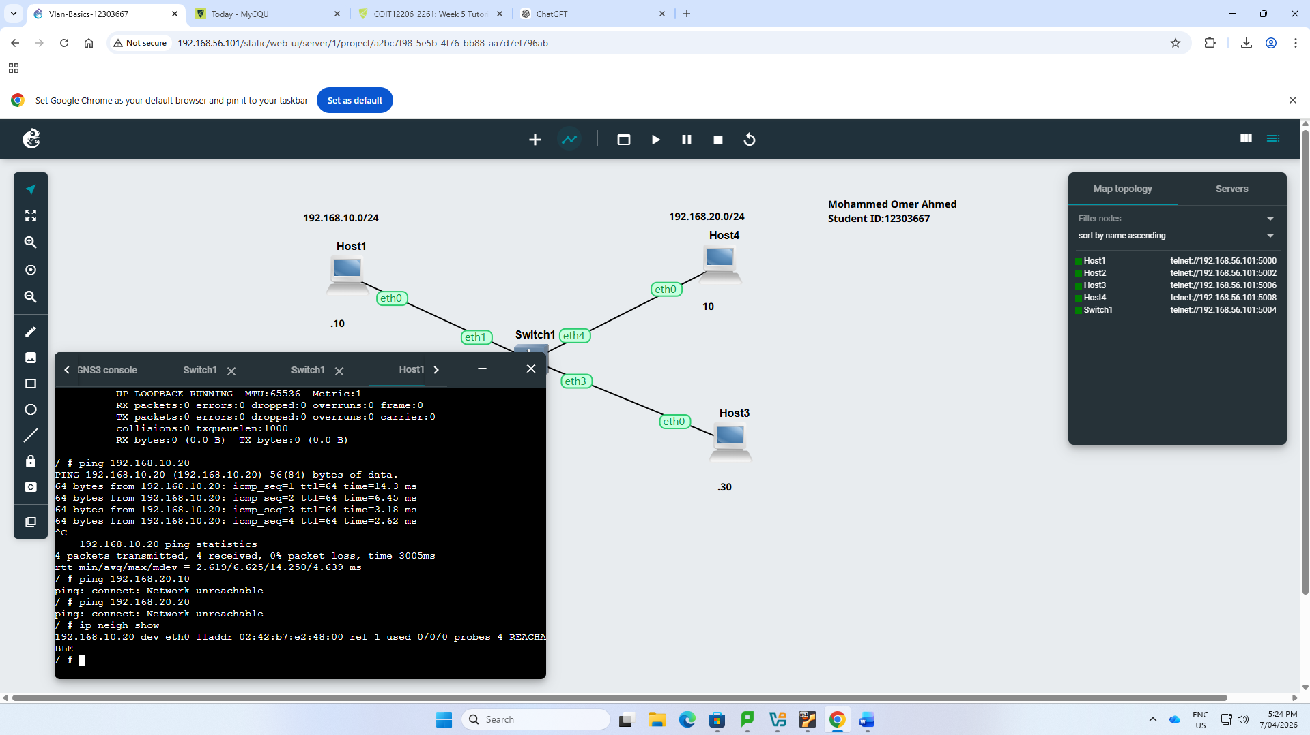
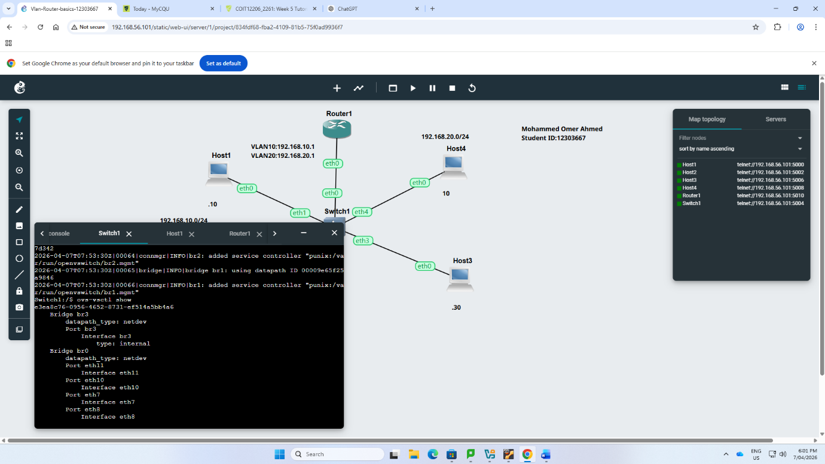
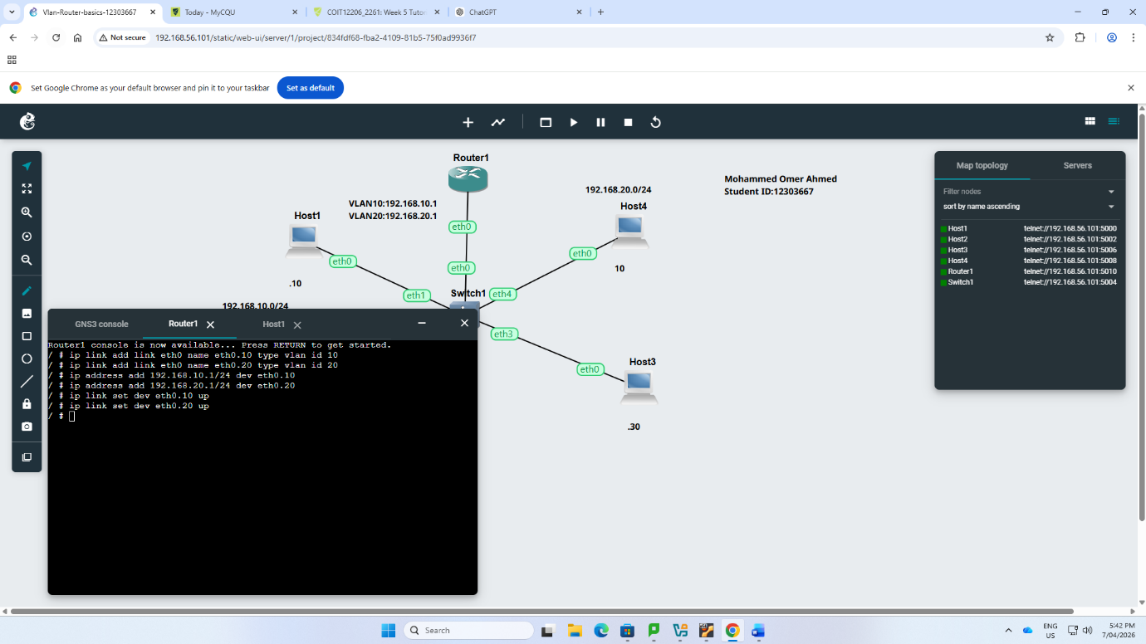

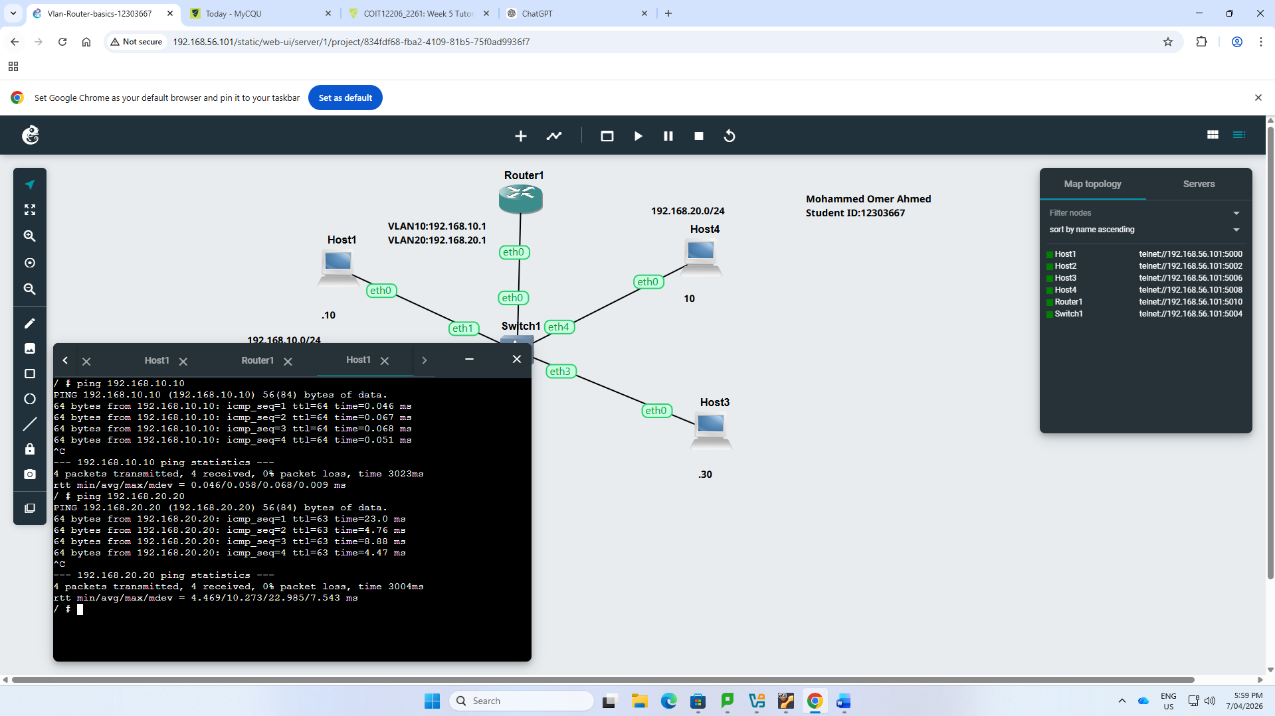
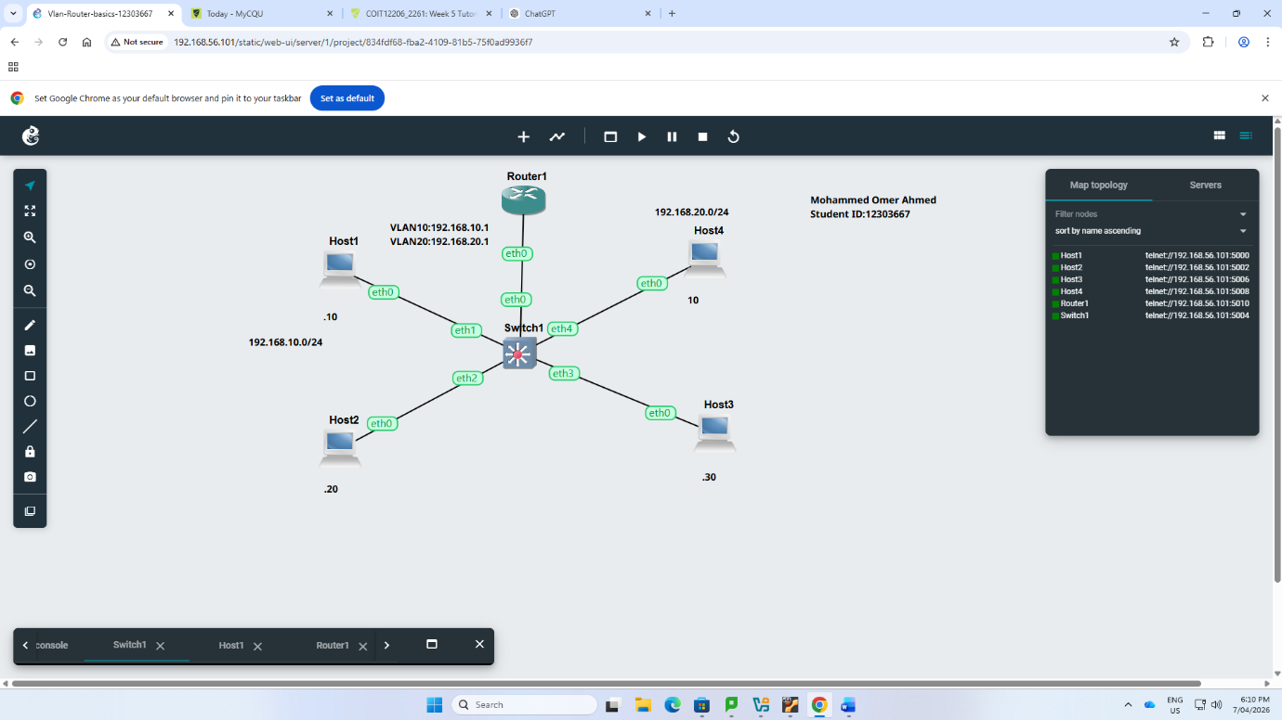

🔍 Reflection

This tutorial gave me an idea of the application of VLANs to isolate network traffic even when devices are connected to the same physical switch. I was taught to tag VLAN IDs to port of the switches and the impact of the same on connectivity between hosts.

Inter-VLAN routing configuration of the router demonstrated how various VLANs can still be communicated using a router. Though the trick of establishing trunk ports and sub-interfaces was somewhat difficult, this enhanced my knowledge about VLANs and network segmentation.

